What to Include in Your Artist Statement
An artist's statement is a short passage written by the artist which provides insight to what the artist was thinking in the creation of their work. It describes the artist's creative process, philosophy, vision, and passion behind their piece. It enlightens and engages, while at the same time gives the audience freedom to draw their own conclusions. Overall, an artist's statement reads easily, is informative, and adds to the understanding of the artist’s work.

When writing an artist statement one should consider the following…
- What is the title of your piece?
- What media was used?
- What techniques were used to create this composition?
- What was the inspiration behind this work/why did you create it?
- Is there any symbolic meaning in your work?
- What message are you trying to convey?
- How does your work reflect you or your style of creating art?
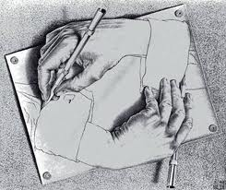
If I could say it in words, there would be no reason to paint… Edward Hopper

